B.E. PROJECT ON

**Spoken Language Identification using Neural Network**

SUBMITTED IN PARTIAL FULFILLMENT OF REQUIREMENTS OF AWARD OF

B.E. (COMPUTER ENGINEERING)

DEGREE OF UNIVERSITY OF DELHI

SUBMITTED BY:

Aditya Jain 210/CO/13

Anmol Pandey 233/CO/13

Anmol Varshney 234/CO/13

GUIDED BY:

Dr. Shampa Chakraverty

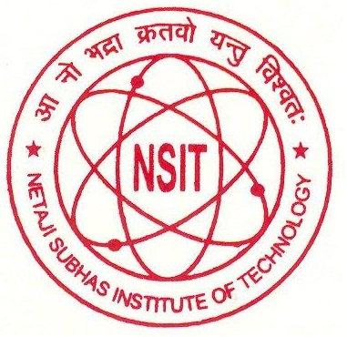

**COMPUTER ENGINEERING (COE)**

**NETAJI SUBHAS INSTITUTE OF TECHNOLOGY**

**UNIVERSITY OF DELHI**

**2016-17**